Doug Theis Newsletter March 2019

**How are you addressing the 10 complexities of your multi-cloud environment?**

Does your organization’s IT infrastructure look something like this?

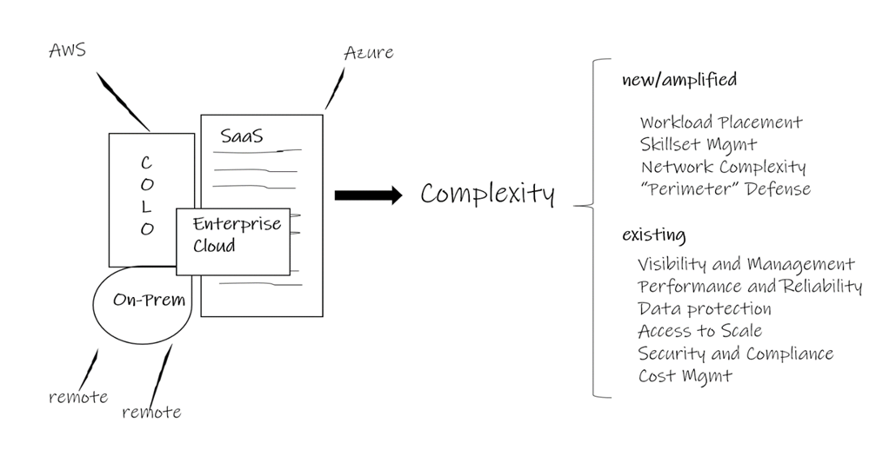

Many of the organizations we meet with have applications spread across multiple platforms including on premises, remote offices, colocation facilities, software-as-a-service (SaaS), hyperscale clouds like AWS and Azure, and enterprise clouds that operate similarly to their in-house environments. Put another way, management complexity is a common byproduct of multi-cloud environments.

**These multi-cloud implementations amplify or carry IT complexity in ten dimensions:**

1. **Workload placement** – Which cloud or hardware platform should I use for each specific application? What are my criteria for choosing the right cloud for the job?
2. **Skillset management** – Do I have the right IT professionals on staff to manage this multi-cloud environment? If not, can I hire the right people for the job, or outsource the work to a combination of managed service providers and cloud service providers?
3. **Network complexity** - Can my existing network team manage this new, complex network that is far different from the LAN and WAN issues they have managed in the past? Is my team capable of architecting, implementing, and supporting a combination of WAN, Internet and direct connections to multiple clouds? Is my combination of WAN, VPN, Internet and direct connections optimized for cost and performance?
4. **Perimeter defense** – How do I draw a defense perimeter around my applications if they exist in multiple clouds? How do I check to see who’s “knocking on the door” across all platforms?
5. **Visibility and management** - It’s difficult enough to get visibility into a homogenous on premises or single cloud environment. How do you monitor multiple clouds simultaneously?
6. **Performance and reliability** – Have my SaaS providers, my cloud vendors, and my implementation team chosen the right cloud platforms for my performance needs? Have I used the right tools in each platform to establish the right level of recoverability for the business to continue operations in the event of a system failure?
7. **Data protection** – Are you appropriately managing safety copies of your data based in on-premises colocation, enterprise clouds, and SaaS platforms? If you’re not protecting your data, is your provider? Does the risk of [data loss](https://www.expedient.com/how-we-help/challenges/data-loss/) and the time to recovery match the lost revenue, profits or credibility that an outage costs the business?
8. **Access to scale** – What is my strategy when the [business grows significantly](https://www.expedient.com/how-we-help/goals/adapt-to-change/)? Do all applications need a highly scalable platform? Do I need the ability to shrink as well as grow?
9. **Security and compliance** - Will the company get fined ([and will I get fired](https://www.expedient.com/blog/nobody-ever-got-fired-for-buying-hyperscale-until-they-did/)) for choosing the wrong combination of platforms for my IT environment? Am I risking a data breach by placing the wrong application in the wrong cloud? How will I know?
10. **Cost management** – How do I know if I’m using [the best cloud platform](https://www.expedient.com/2019-cloud-spectator-report/) from a cost perspective, or if I’m [spending too much](https://www.expedient.com/how-we-help/challenges/budget-management/)? How do I put guard rails around both my infrastructure team and my development team so they don’t overrun annual cloud and telecom budgets in the first three months?

Looking for a solution that can help you manage multi-cloud complexity rather than amplifying it? [Contact me](mailto:doug.theis@expedient.com) for a conversation about your environment to evaluate your unique IT complexities and to help you determine the right combination of cloud platforms and management tools to effectively manage your multi-cloud environment.

**DRaaS options grow, but no one size fits all**

If enterprises have defined their disaster recovery needs and validated vendor capabilities, DRaaS can make it easier to weather service outages.

AutoNation spent years trying to establish a disaster recovery plan that inspired confidence. It went through multiple iterations, including failed attempts at a full on-premises solution and a solution completely in the cloud. The Fort Lauderdale, Fla.-based auto retailer, which operates 300 locations across 16 states, finally found what it needed was a hybrid model featuring disaster recovery as a service.

“Both the on-premises and public-cloud disaster-recovery models were expensive, not tested often or thoroughly enough, and were true planning and implementation disasters that left us open to risk,” says Adam Rasner, AutoNation’s vice president of IT and operations, who was brought on two years ago in part to revamp the disaster recovery plan.

The public cloud approach sported a hefty price tag: an estimated $3 million if it were needed in the wake of a three-month catastrophic outage. “We were probably a little bit too early in the adoption of disaster recovery in the cloud,” Rasner says, noting that the cloud providers have matured substantially in recent years.

More of the Network World article from Sandra Gittlen

https://www.networkworld.com/article/3337463/cloud-computing/draas-options-grow-but-no-one-size-fits-all.html

**4 best practices to help organizations succeed in a hybrid cloud world**

ESG Research Insights paper describes behaviors organizations should adopt to improve multi-cloud management.

Hybrid cloud continues to grow in popularity, fueled by its agility and scalability. Yet, many organizations realize that a hybrid cloud model (a combination of private, on-prem, and public cloud) also introduces complexity, which slows innovation. A hybrid model also makes it more difficult to view global utilization or track and control costs.

A recent ESG Research Insights Paper, Multi-cloud Management Maturity, Tangible Reasons Management Excellence Is Required in a Hybrid Computing World, details how organizations are managing heavily hybridized environments. In the paper, ESG surveyed 600 IT decision makers in organizations of at least 1,000 employees to determine a multi-cloud management maturity score.

Those surveyed use public cloud for nearly a quarter of their workloads – and the majority utilize multiple cloud service providers. They also implement on-premises workloads in the following percentages:

37% of on-premises workloads are run on traditional physical servers.

36% are run on VMs that are still predominantly managed as traditional servers.

27% are run within a private cloud that inherits the core attributes of public cloud services.

More of the CIO.com article from Gary Thorne

<https://www.cio.com/article/3342996/leadership-management/4-best-practices-to-help-organizations-succeed-in-a-hybrid-cloud-world.html>